OUTPUT

1.

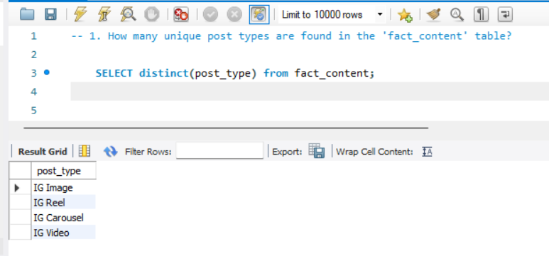

2.

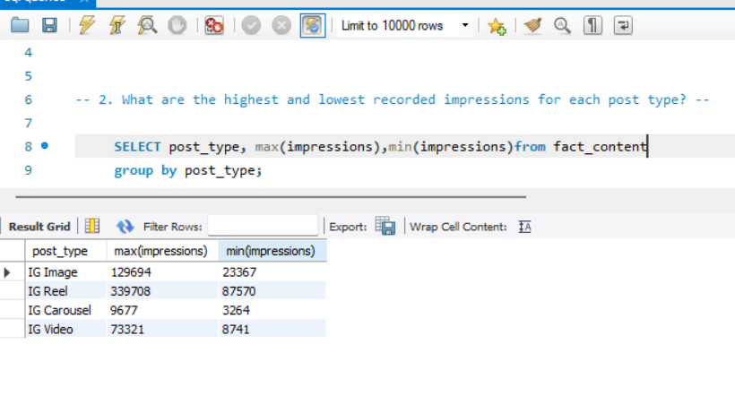

3.

4.

5.

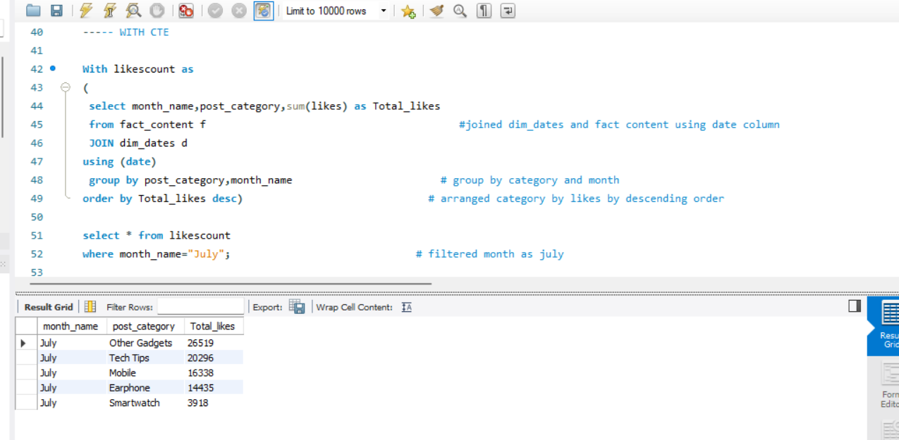

6.

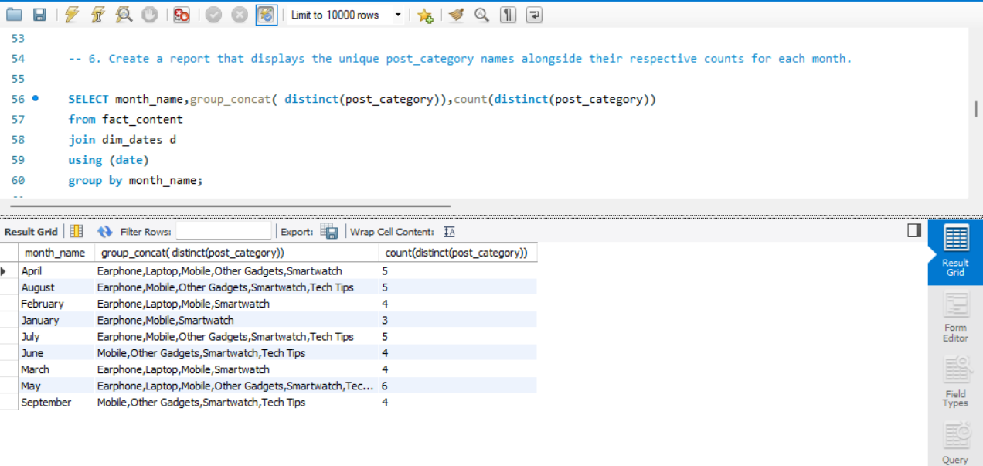

7.

8.

9.

10.

